Assignment 2.1:

Checking whether /user/acadgild directory exists or not in the HDFS

/user/acadgild directory exists in the HDFS:
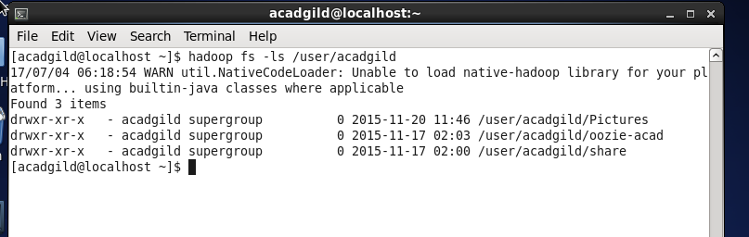

Creating a directory ‘hadoop’ under ‘/user/acadgild’:
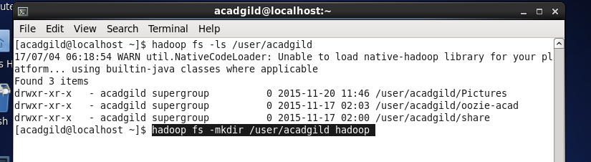

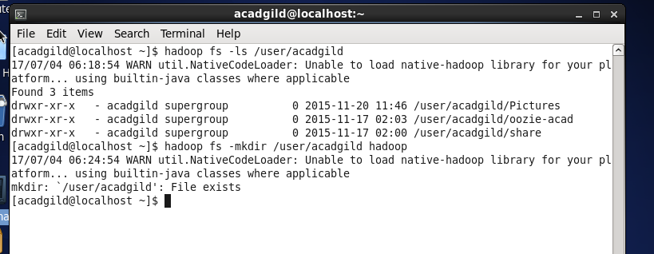

Created directory /user/acadgild/hadoop:
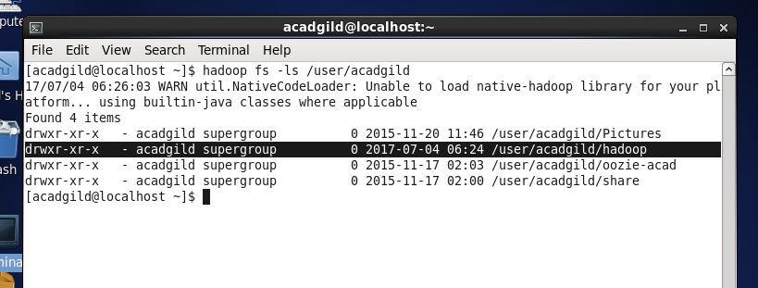

Task2:

Creating a file in HDFS under directory /user/acadgild/hadoop with name word-count.txt

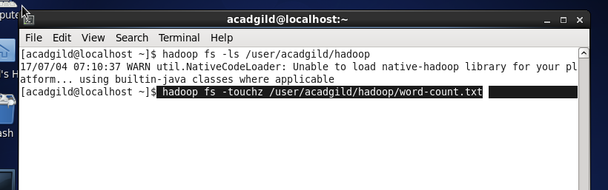

Word-count.txt file is created in HDFS under directory /user/acadgild/hadoop
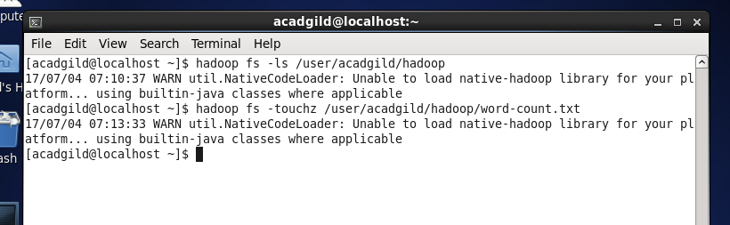

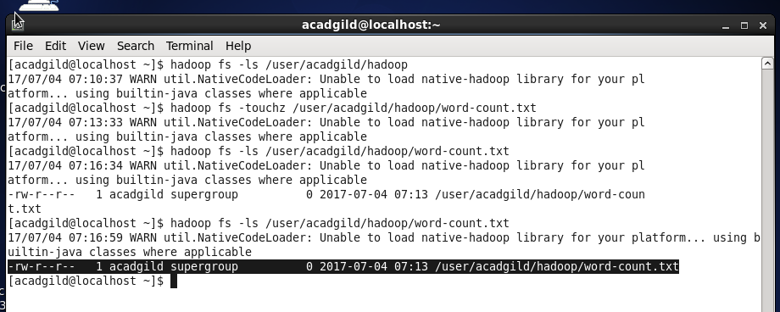

Typed text “First Line” on screen getting written in to the file word-count.txt
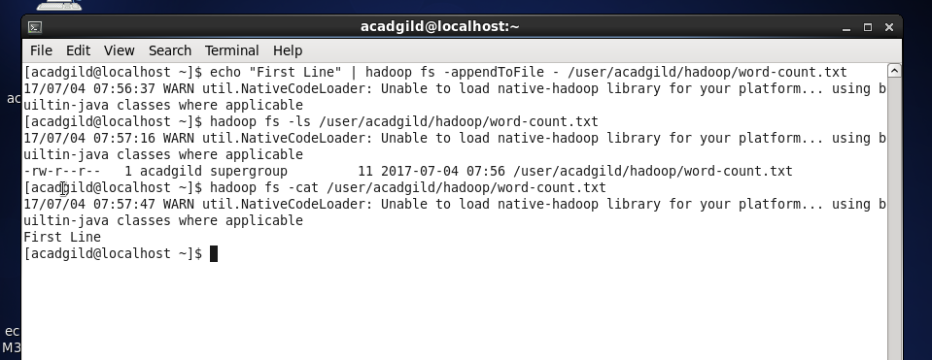

Adding few more lines, appending text to file ‘word-count.txt’:
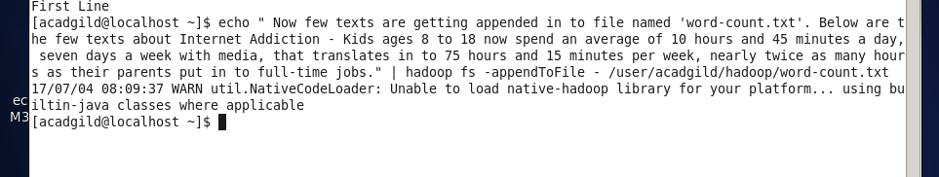

Viewing the complete text entered in to ‘word-count.txt’ file:
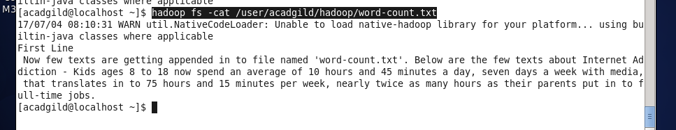
File size of “word-count.txt” is increased, since more text is added / appended in to file:
